Tianle Yuan
CS 550
November 23, 2020
Project 6

Name: Tianle Yuan
Email: yuant@oregonstate.edu
Project Number: 6
Project Name: Shaders
Web Link: https://media.oregonstate.edu/media/t/1_p94mk1em
Screen Captures：
My “3D flower” has 12 petals; each petal includes 4 3D curves drawn by 7 points.
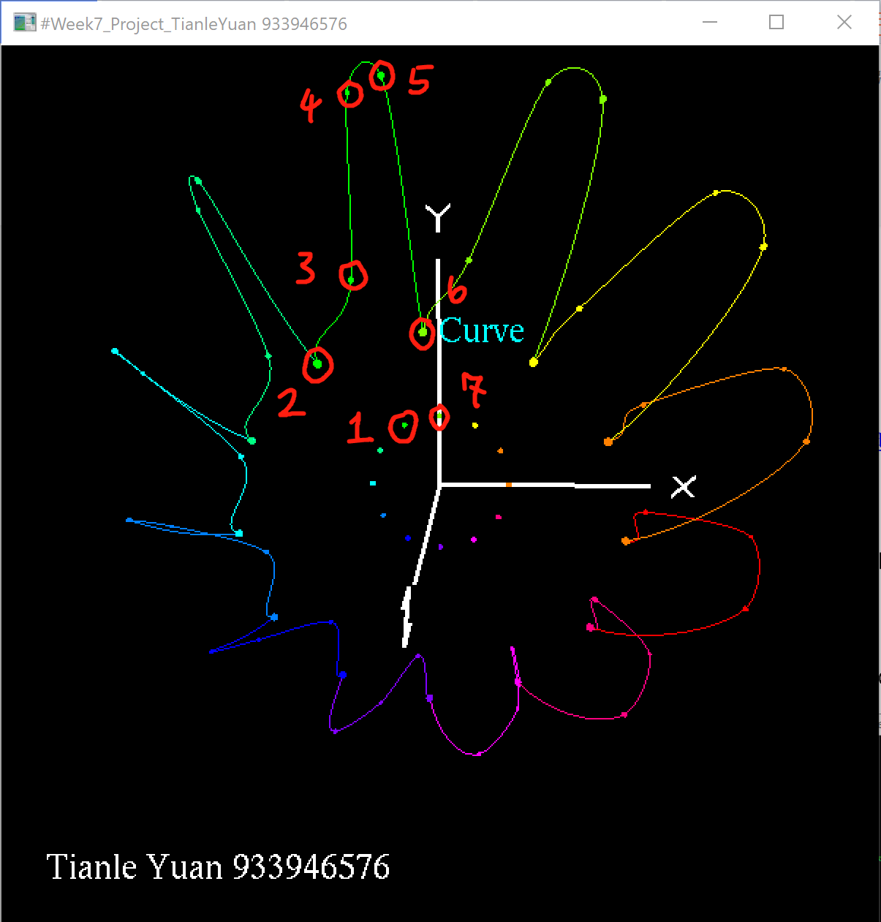
Turning points on and curves off; Turning points off and curves on; Turning on both points and curves;
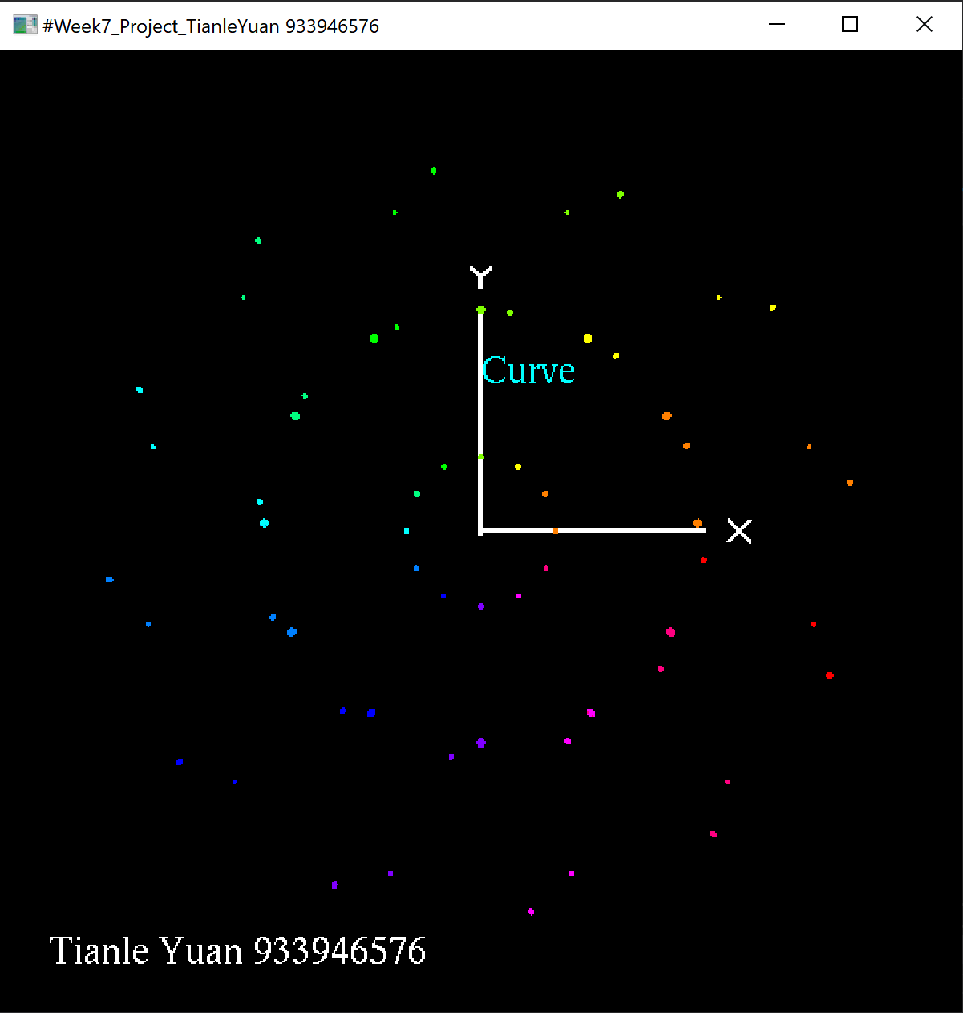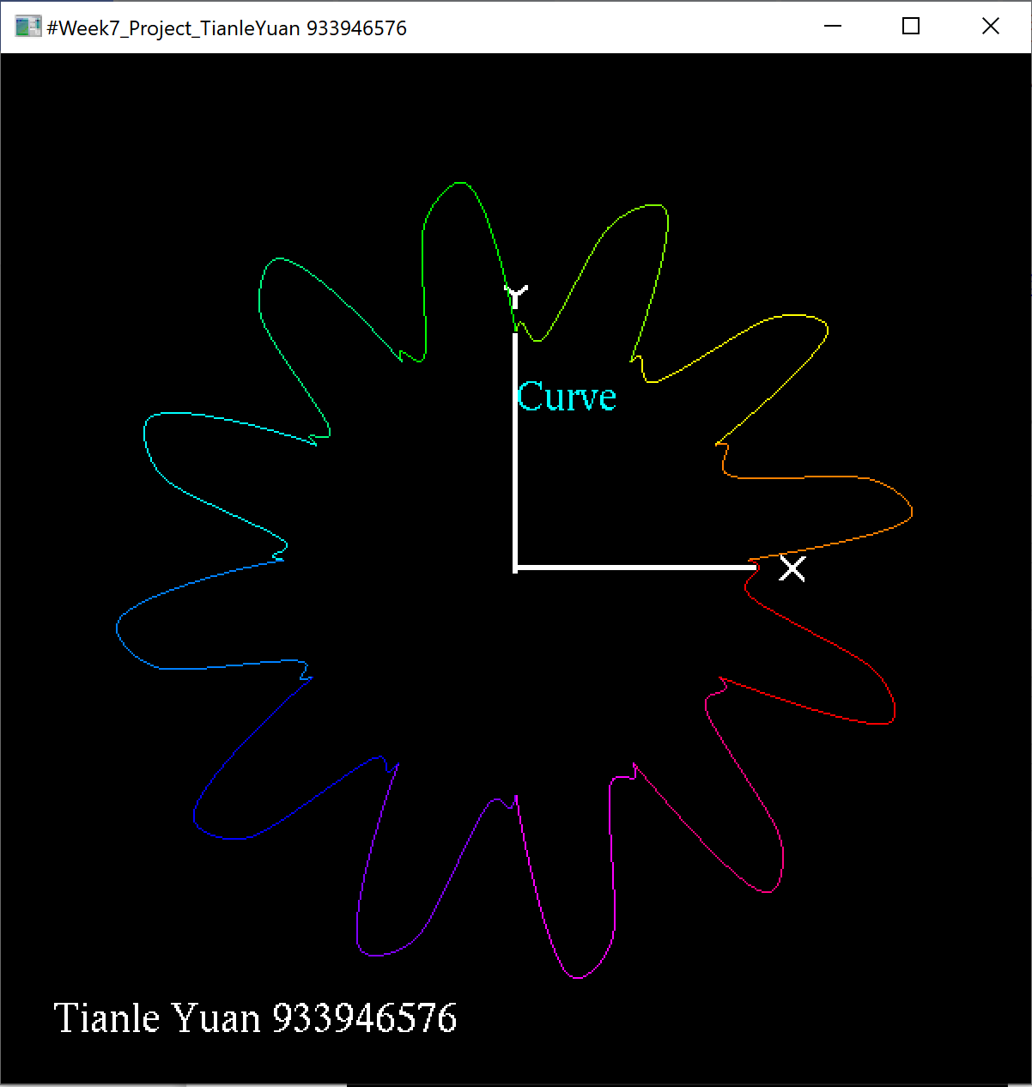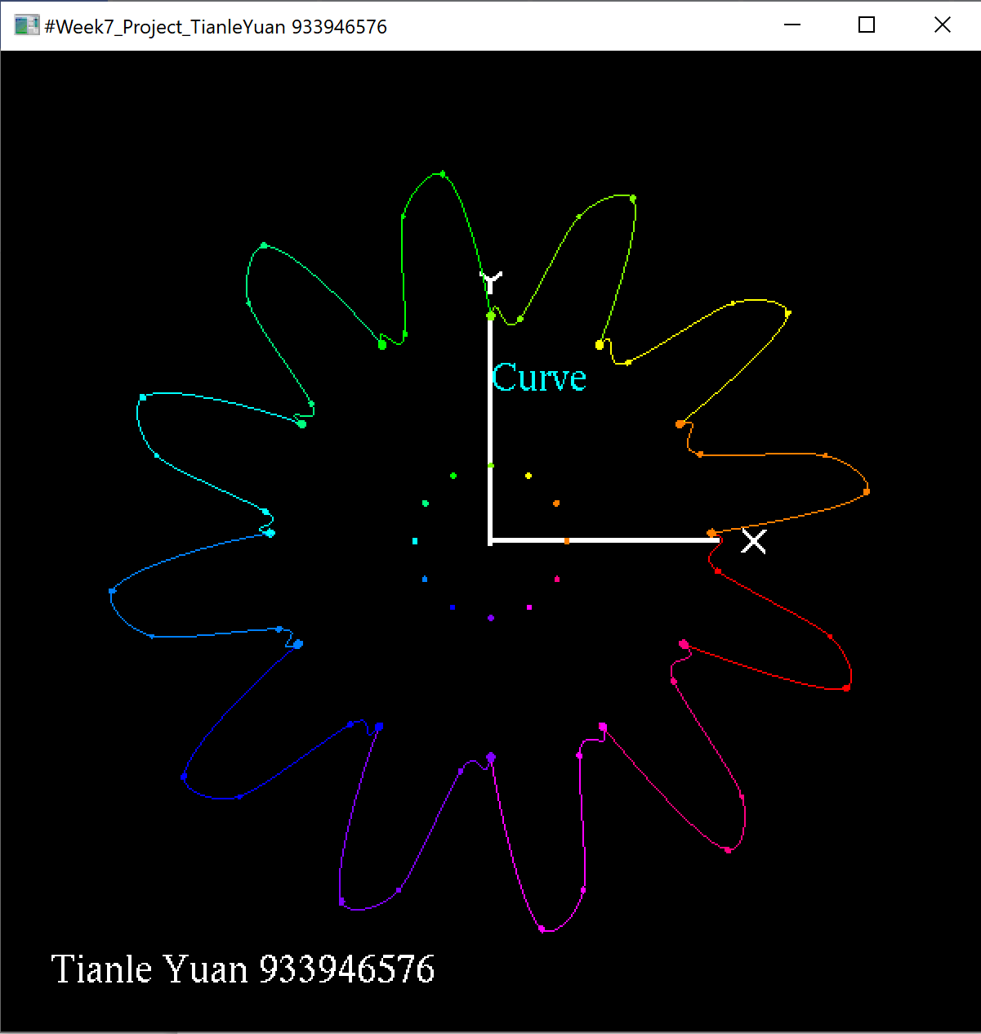
Animating(points on and curves off); Animating(points off and curves on); Animating(both points and curves on);
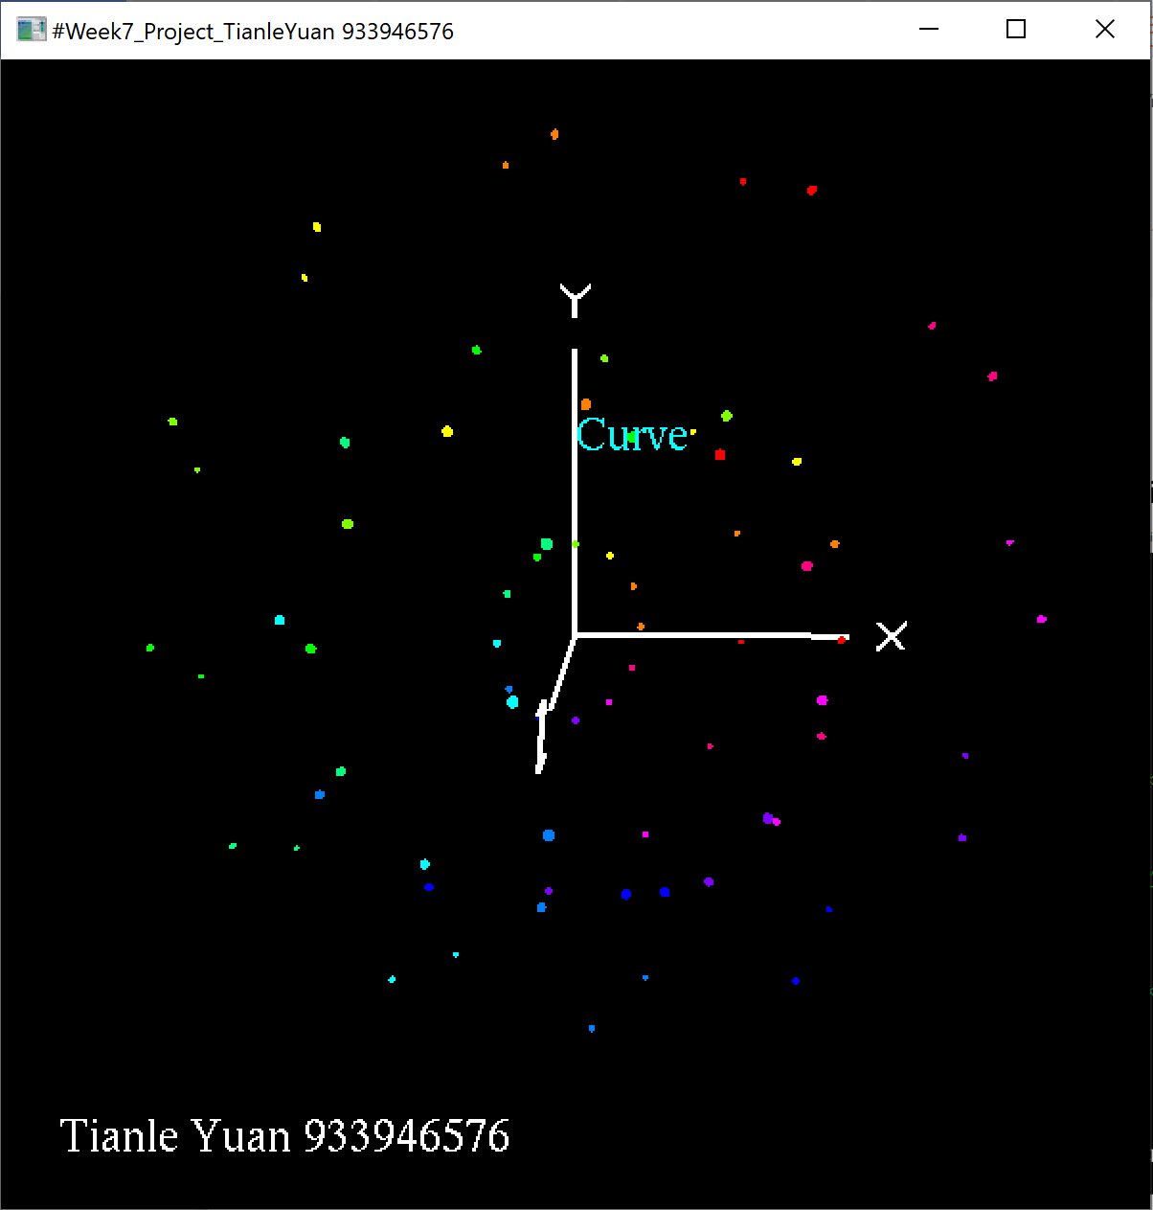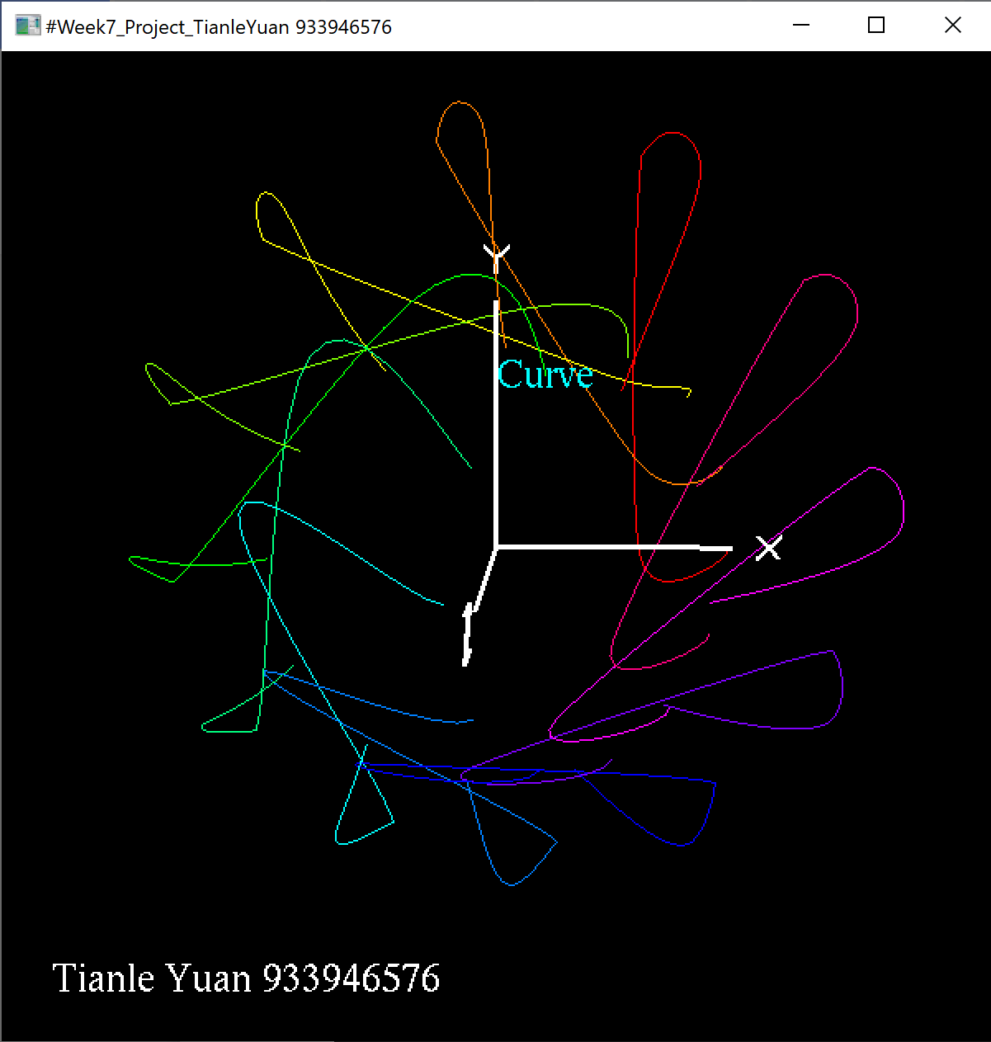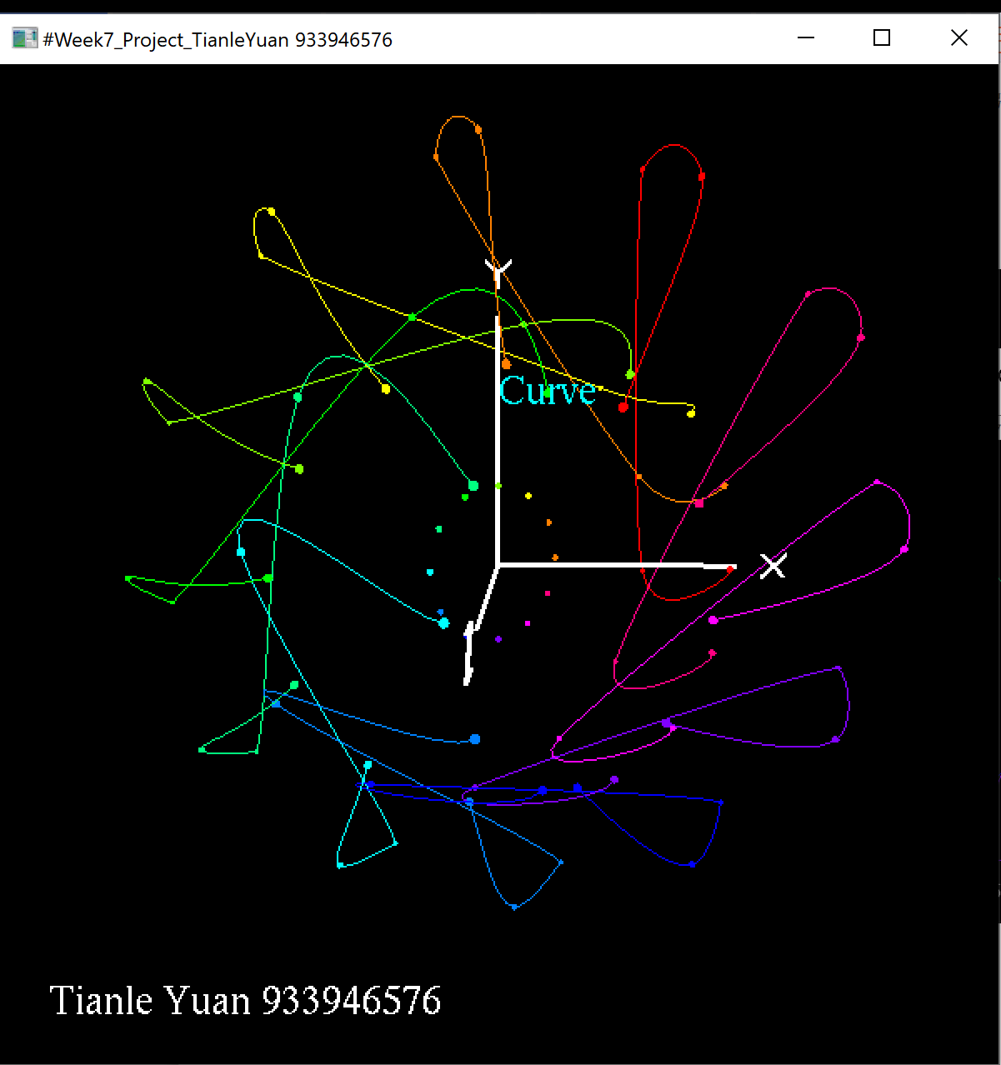
Note: Points 1,2,3,6, and 7 are rotating with Y axis; Points 4 and 5 are rotating with Z axis.

